|  |  |  |
| --- | --- | --- |
|  | European Banking Authority  One Canada Square (Floor 46) Canary Wharf London E14 5AA |  |
|  | Your reference: EBA/CP/2015/17 |  |
|  | 21 January 2016 |  |
|  |  |  |

Dear Sirs

CONSULTATION PAPER ON DRAFT GUIDELINES ON COMMUNICATION BETWEEN COMPETENT AUTHORITIES AND AUDITORS

**Introduction**

1. The Global Public Policy Committee’s (GPPC) Bank Working Group welcomes the opportunity to respond to your October 2015 consultation paper. In previous discussions and consultations including with the Financial Stability Board and the Basel Committee of Banking Supervisors we have argued that improved communication between supervisors and auditors is an important measure for supporting financial stability.
2. We are therefore very pleased to see that the European Banking Authority (EBA) is focussing on increasing the communication between auditors and supervisors, and we strongly support the principles in the paper.
3. The Bank Working Group is comprised of members with bank audit expertise from the six largest audit networks: BDO, Deloitte, EY, Grant Thornton, KPMG, PwC and sits under the GPPC. The GPPC’s public interest objective is to enhance quality in auditing and financial reporting.

**Key points**

1. We are keen to ensure that the proposals work in a manner that effectively supports the financial stability objective, and hope that our comments make a constructive contribution to this end.
2. We believe that the flow of information from supervisors to audit firms makes a direct contribution to audit quality through assisting auditors in making judgments on risk. We recommend that the guidelines clearly provide for a two-way exchange between auditors and supervisors.

1. We have some concerns about the application of the proposals in practice, particularly in relation to confidentiality requirements for banking groups with operations outside the EU. Effective communication will be most important in relation to global credit institutions that pose the greatest systemic risk and the guidelines could provide more detail as to how the dialogue will work in relation to such firms.
2. Our understanding is that most of the communication is expected to occur in bilateral meetings. However, there are references to ‘information sharing’ which could be interpreted as authorising supervisors to request (potentially extensive) written material from auditors. We do not think this is the outcome sought and the guidelines could be clearer in this respect.
3. The financial stability objective of the institution-specific communications is important. We think this objective may be compromised or confused if audit oversight bodies were to participate and the focus of meetings were to shift towards the regulation of auditors. For this reason, we do not consider that the participants in the institution-specific communications should include audit oversight bodies.

We are of course comfortable with a wide range of participants, including audit regulators, taking part in the communications on wider themes affecting the industry. The Bank Working Group stand ready to help to organise the collective meetings.

1. We propose a review of the guidelines takes place after implementation to ensure they are working effectively. The Bank Working Group would be willing to contribute to this if the EBA would find it helpful.

Please do not hesitate to contact either of us should you wish to explore these topics further.

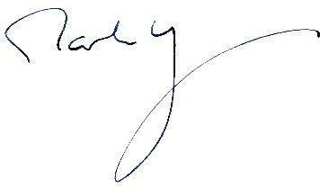 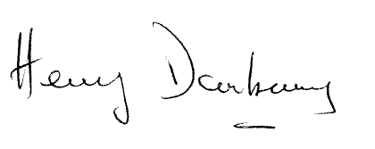

Mark Rhys Henry Daubeney

Co-chair, Bank Working Group Co-chair, Bank Working Group

Deloitte LLP, London PricewaterhouseCoopers London